**Assignment(30-12-2023)**

**Program 1:**

In these program we are performing the Pyspark literals in azure Databricks Environment ,we are displaying data with help of Dataframe in table format as a output.

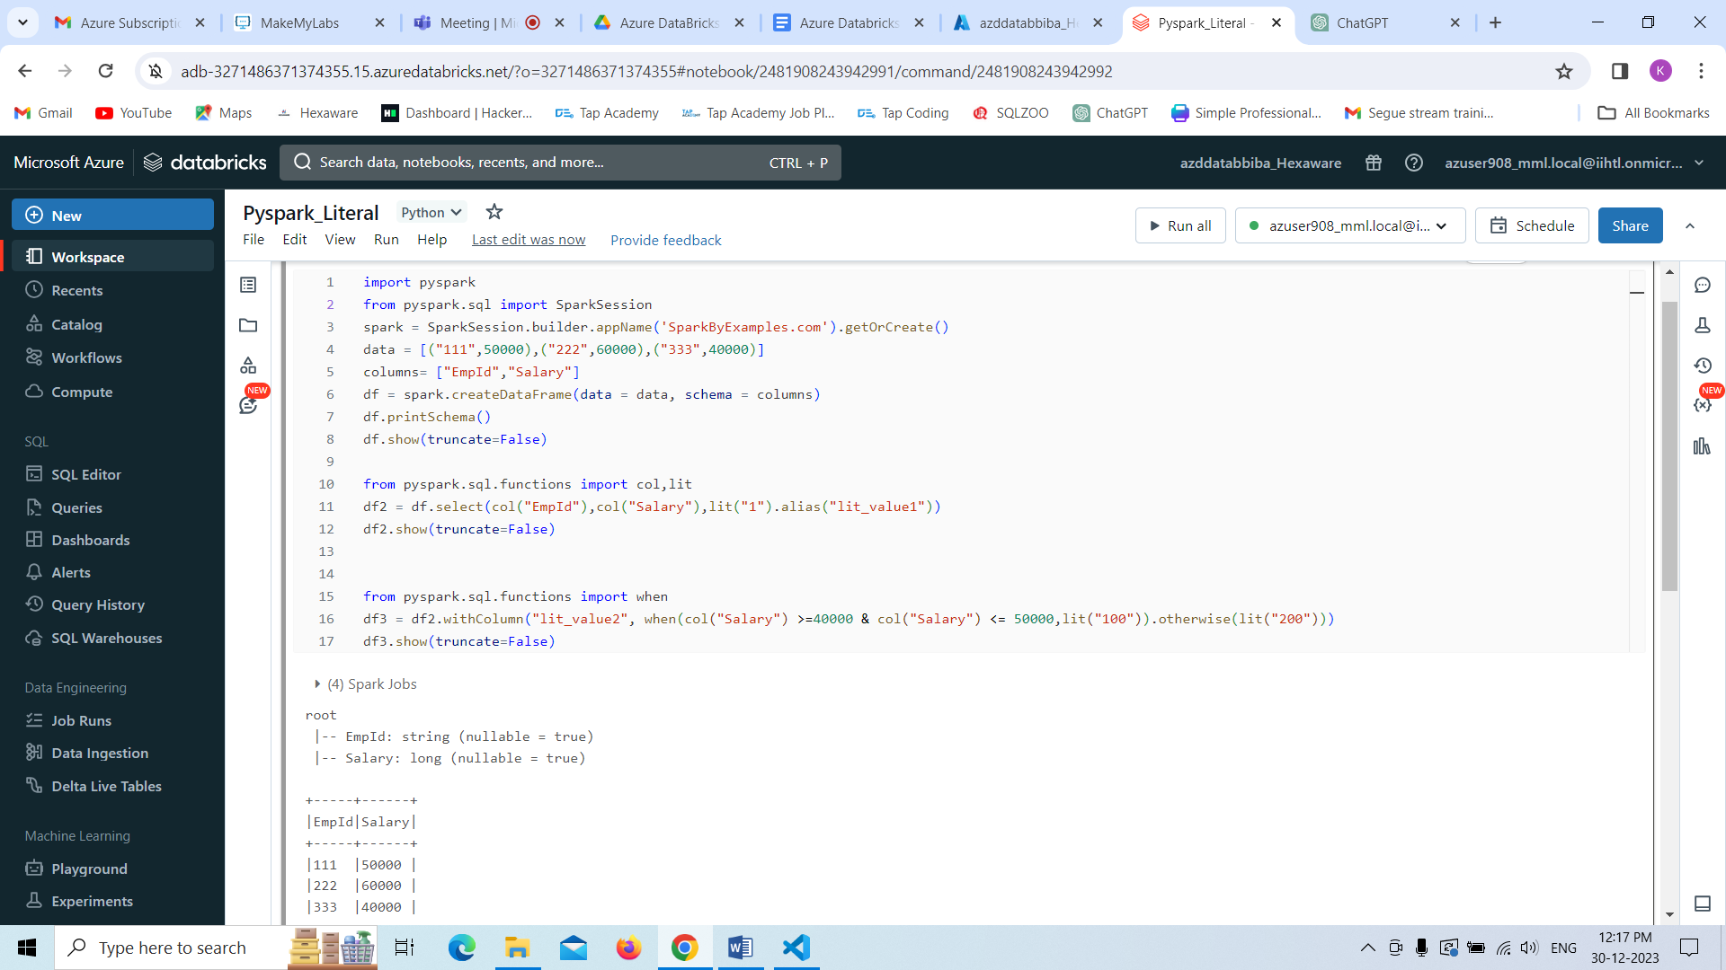

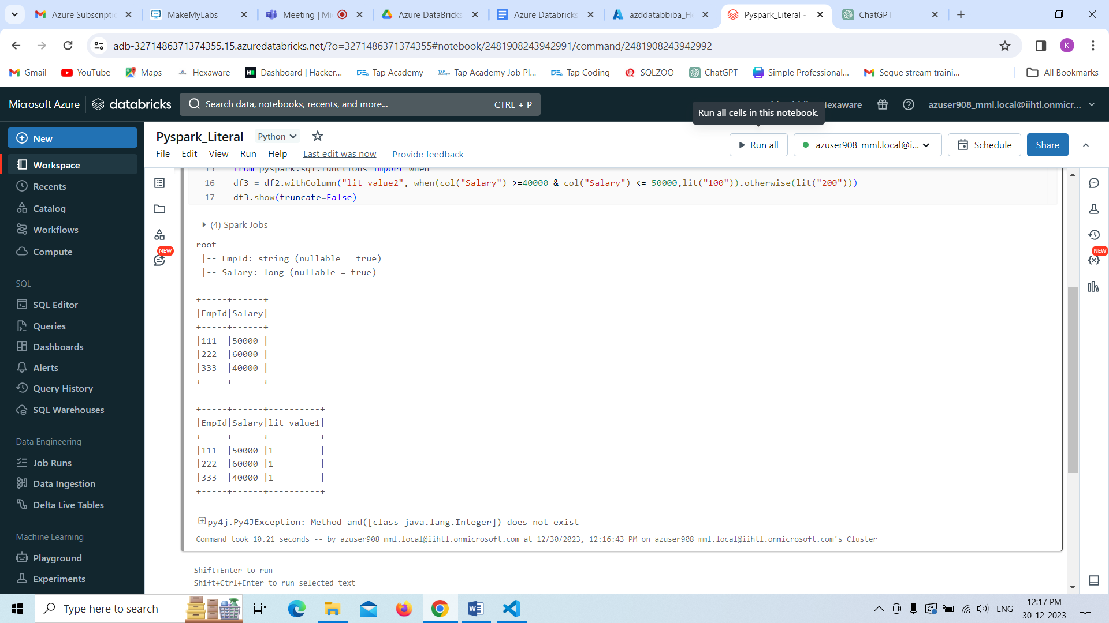

**Program 2:**

In this program, we are performing joins with two tables in pyspark environment and displaying those tables data as a mixed table as result as output.

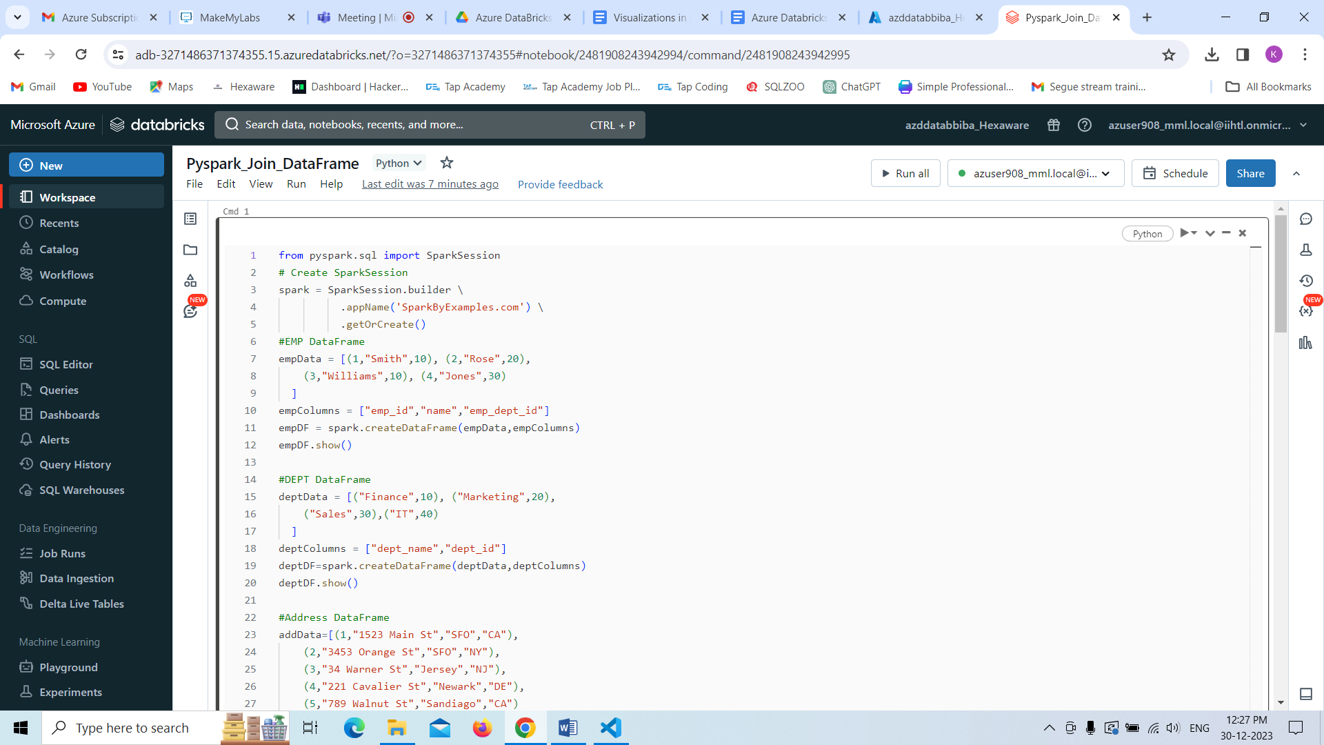

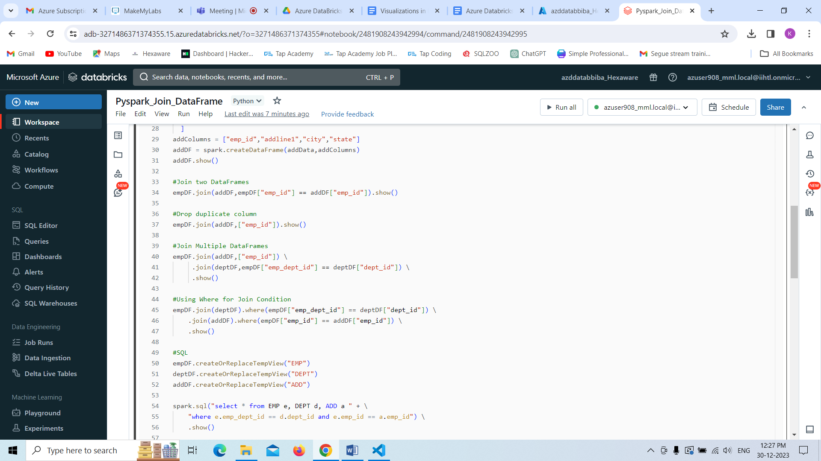

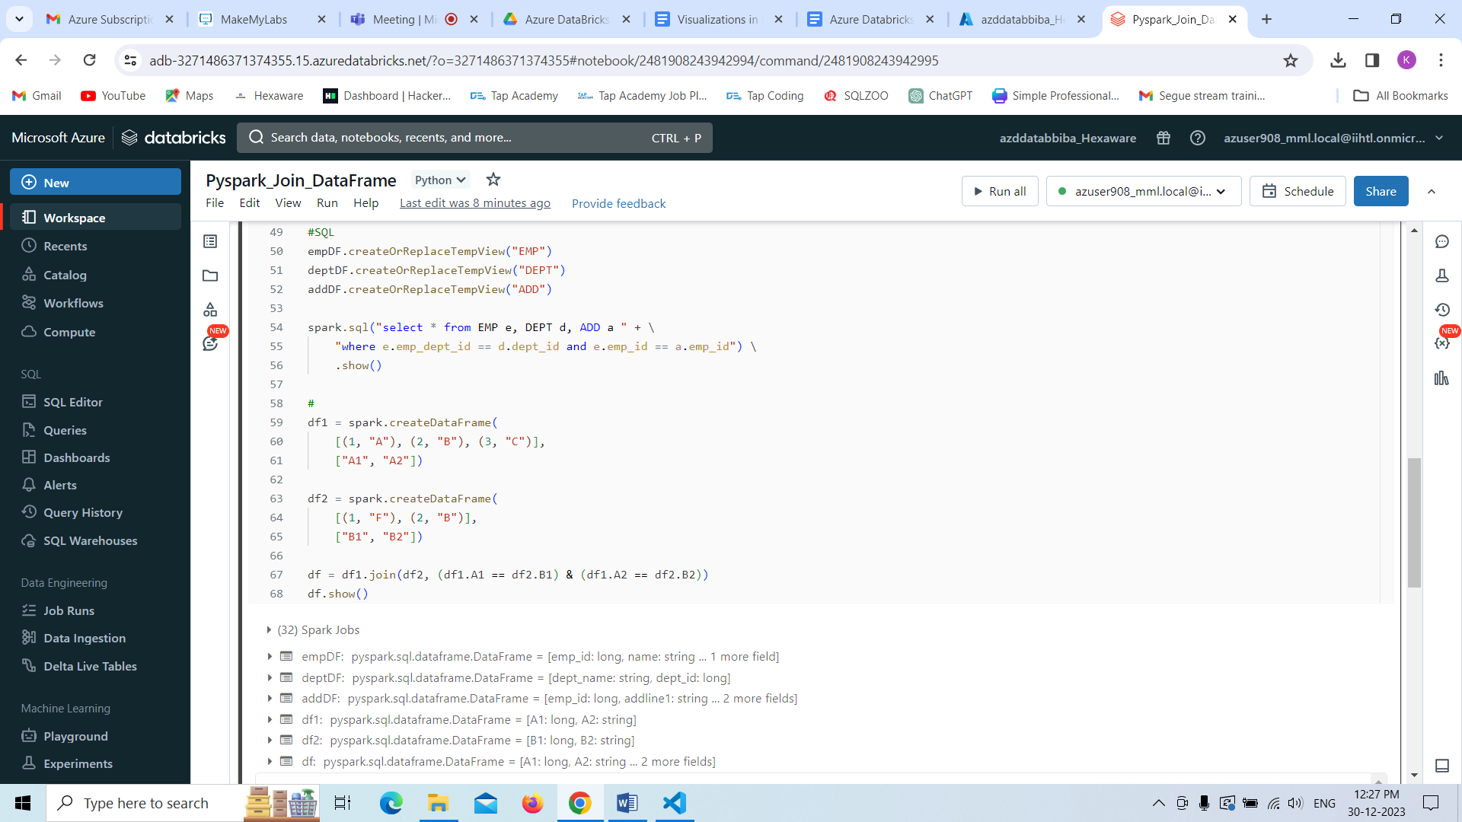

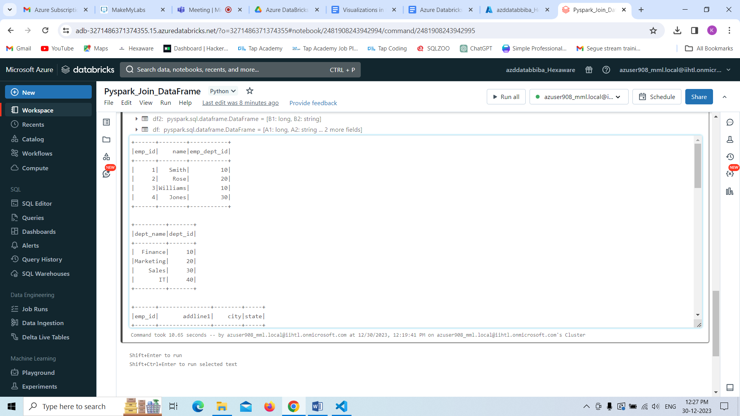

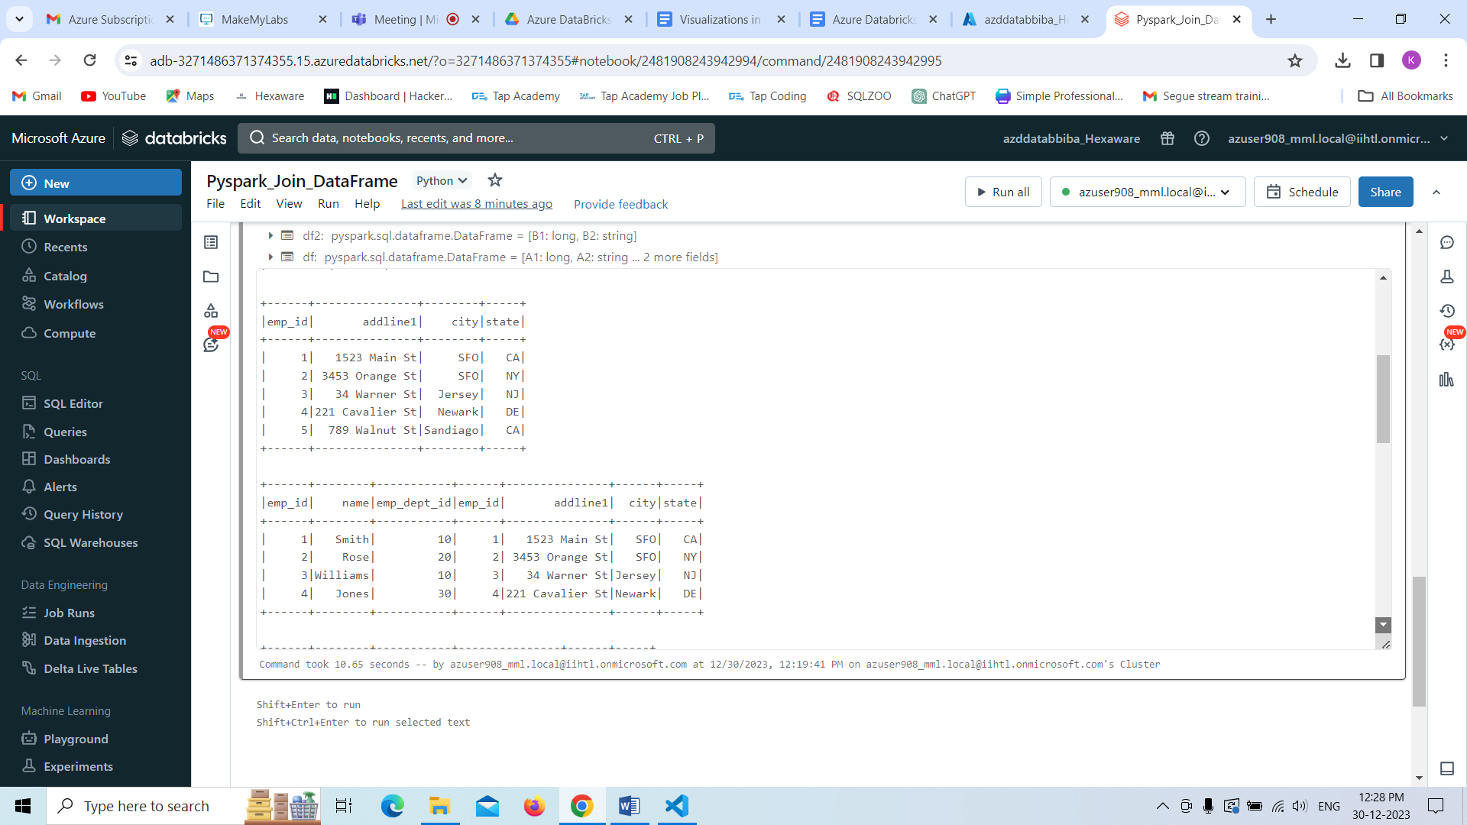

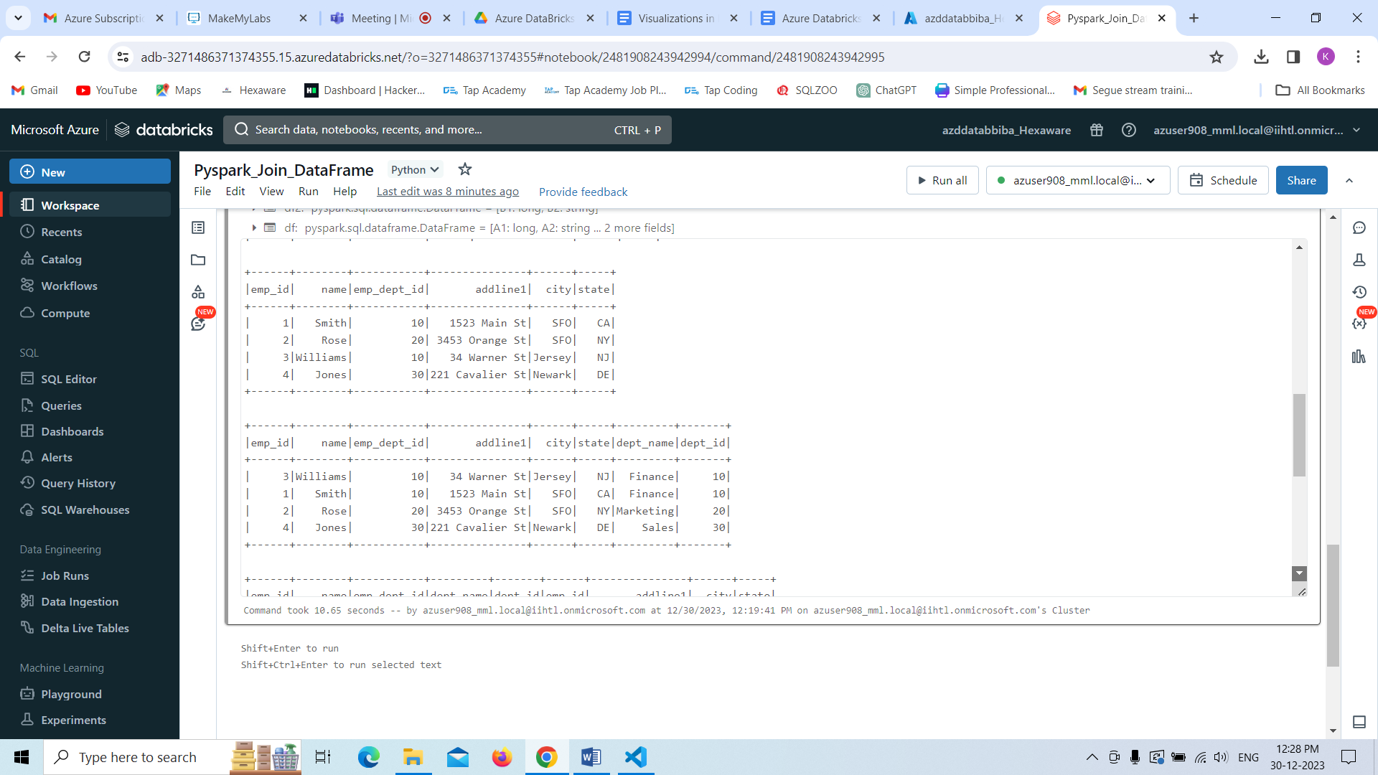

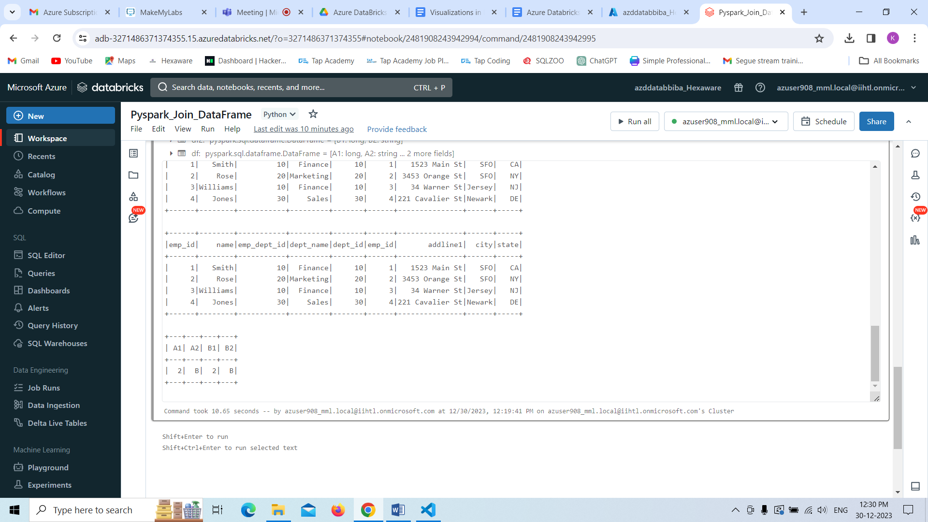

**Data Visualization**

Databricks has built-in support for charts and visualizations in both Databricks SQL and in notebooks. This page describes how to work with visualizations in a Databricks notebook.

